

VM Resource Management Policy
Research Computing Team

Version 1

Document History and Reviews

Version | Date | Revision Author | Summary of Changes
0.1 | Oct 2020 | Vinisha Pillai | New policy
0.2 | Nov 2020 | Vinisha Pillai | Minor changes by peer feedback
1 | Dec 2020 | Vinisha Pillai

Review Distribution

Approval

Name | Position | Signature | Date
 |  |  | Dec 2020

Contents
1. Introduction 3
2. Scope 3
3. Criteria for Requesting VM resource 3
4. Information Collection 4
5. Managing Privileges on the Virtual Machine 4
6. Managing Elevated Privileges on the Virtual Machines 5
7. Procedure for VM creation 5
8. Procedure for VM Decommissioning 6
9. Flow Chart for User Creation and Decommissioning Process 6
10. Policy Review and Maintenance 7
11. Supporting Policies and Documentation 7
12. Advice 8

Introduction
  - This policy covers the following aspects of governing KU VM Resource Management for the Research Computing Team:
    - Criteria’s for VM requests.
    - Access control policies.
    - Information collection.
    - Managing Privileges.
    - Procedures of VM Creation.
    - Deletion of VM resources.

Scope
  - This policy applies to KU virtual environment systems managed by Research Computing Team on behalf of Khalifa University.

  - This policy applies to all users who needs access to the VMs.

  - This policy applies to all Research Computing members responsible for the VM resource management.

  - All University faculty members who has line management responsibilities are requested to comply with paragraphs 5.4 and 5.5 below. (Optional)

Criteria for Requesting VM resource

VM resource can only be requested from Research Computing team if any one of the below criteria are met.

  - Any Faculty member in Khalifa University who has a valid computing resource requirement for a Virtual Machine.

  - Any student or researcher who is sponsored by a faculty member of Khalifa University and has a valid computing resource requirement for a Virtual Machine. In such cases, there should be approval from the faculty member or the advisor.

  - User who has computational needs that is not fit for HPC environment and is working with application that is not parallel or distributed in nature.

  - User who works with graphical applications that needs interaction and needs resources that doesn’t fit in laptop or workstation.

  - User who works with Windows applications and doesn’t have resources to work on. The requirements of such user doesn’t fit in the VDI also.

  - User needs access to centrally installed applications which are Linux based like Synopsys, Cadence etc and has licenses hosted on IT VM resources.

  - User needs a shared facility for his/her team to work on Linux based applications.
In such cases, more details need to be provided like how many members in the team needs access to the VM resource, applications used for the projects, details of projects for which the VM resources are being used, details of users and their departments/groups and level of access required on the VMs.

  - User wants to host a website in the VM resource.
In such cases, more details need to be provided as below:
    - Purpose of hosting the website.
    - Details regarding developer of the website and the level of access needed.
    - Details if any external developers are included.
    - Define the tools/technologies involved.
    - Define the OS requirements and the application requirements for the website.
    - Details regarding the URL, SSL requirements need to be defined.
    - Details if the website will be published outside of KU. Involvement of KU Communication team should be clarified in such cases.
    - Details regarding access from any other servers inside network.
    - Details regarding the data flow for the website.

Information Collection
User who needs access to the VM resources in KU should provide with the below information to Research Computing Team.
- User information: -
- User needs to define his/her role in Khalifa University, whether he/she is a Faculty or Student or a Researcher.
- If the user is not a faculty, then he/she needs to provide details about his PI/advisor.
- User needs to provide an approval email from his advisor for requesting for VM resources.
- Resource requirement details: -
- User need to provide the purpose of the VM and need to justify the need for a VM.
- User need to provide information about the applications he/she needs on the VM.
- User need to provide information regarding the resource requirement i.e. OS, CPU, Memory and hard disk details.
- User needs to clearly provide the list of users who needs access to the VM and the define the level of access that is needed for the users.
- User needs to specifically define the management details of the VM i.e. specify whether the VM should be managed or unmanaged.
- User need to provide the storage requirement for the VM and specify the growth rate of the data in the VM.
- Project Information: -
- User needs to provide information on the project for which the VM resources will be used which includes Project name or Title, Project code, Project summary and the name of the research Centre which this project is part of.

Managing Privileges on the Virtual Machine
  - A user account should have the least privilege that is sufficient for the user to perform their tasks in the Virtual Machine.

  - If a group has project directories assigned for them, then a user or users in that group can have elevated permissions to their project directories.

  - Changes in the privilege of an account to their project directories, must be authorized by the user’s advisor or faculty.

  - Faculty or the group owners are responsible for ensuring that access rights of the users in their group are adjusted appropriately, and in a timely manner, whenever there is a change in project need, a user changes their role, or a user leaves the University. This can be achieved by sending an email to Research Computing team or by logging a call with the service desk.

  - Generally, user accounts in the Virtual Machine should be disabled immediately once the user leaves the university or after a period agreed with HR. However, there are some staff that are permitted to have access to their emails or servers or folders once they have retired for continuation of their projects. As such, the user’s faculty or the group Owner will inform Research Computing team and confirm about the user’s data. Once the user has retired it is the group Owner’s responsibility together with HR to inform the RC team about the access to the VM and about the user data. Note that the user’s data will not be deleted until after a period agreed with group owner or Human Resources.

  - Users should be informed of their responsibility to inform their Faculty or group owners of any change in their role which might affect their privileges to the VM. IT Infrastructure team also should be informed as part of the starters/leavers process.

Managing Elevated Privileges on the Virtual Machines

  - Users whose work requires system administration access will be given a separate specialist account in LDAP for this purpose, in addition to their standard user account for managing the VM resources.

  - System administration accounts are created and managed in Active Directory/LDAP which is shared between multiple systems and platforms.

  - These system administration accounts should be managed and the user is responsible for them similar to standard accounts. The password policy also applies to the system administration accounts.

  - Line managers are responsible for taking action to remove user’s admin account from the VM when they move roles. This should be achieved by logging a call with the Service desk.

  - System administration accounts will automatically be disabled when the users leave the university.

Procedure for VM creation

  - User contacts Research Computing team to provide access to the VM resources.

  - RC team initiates the information collection process.

  - Once user get backs with his details and requirement, Research Computing Team conducts a meeting with the user to analyze his requirement and thereby to decide whether to give user access to the VM.

  - RC team get confirmation from user’s supervisor or faculty regarding project association and group details.

  - The project details will be stored in the database and linked to the correct research Centre. This is for accounting purposes.

  - RC Team contacts Ankabut team and allocates the resources for VM.

  - RC Team configures the VM with required applications and customizes the VM as per user requirement.

  - In case of Linux VMs, RC team contacts Ankabut team to enable Linux attributes to the users and also add him/her to specific groups for accessing shared project directories on the VM.

  - Once details are received from Ankabut team, the users are configured on the VM with home directory and quota setup.

  - The VM is handed over to the users for User Level testing.

  - Email will be sent to the users with instructions on how to login to the VM.

  - Relevant trainings are given to the user for customizing his environment for the application he will be working on.

  - RC team closely works with users for any issues and make sure the VM is fully ready for the user to start using.

Procedure for VM Decommissioning

Below are the two different reasons for which the VM will be decommissioned

    - Faculty requests for VM decommissioning as he/she no longer need the VM as the project for which the VM was being used is completed.
    - The user who works on the VM is planning to leave the university and the VM is no longer needed for the team. Faculty confirmation is needed for this case.

Procedure of VM Decommissioning is as follows:

  - Upon receive of request to decommission VM, RC Team collects information from the faculty on whether Users data or project data needs to be backed up on the VM.

  - Required data is backed up from the VM and delete the VM.

  - Notify faculty regarding the changes done and hand over data if any.

Flow Chart for User Creation and Decommissioning Process

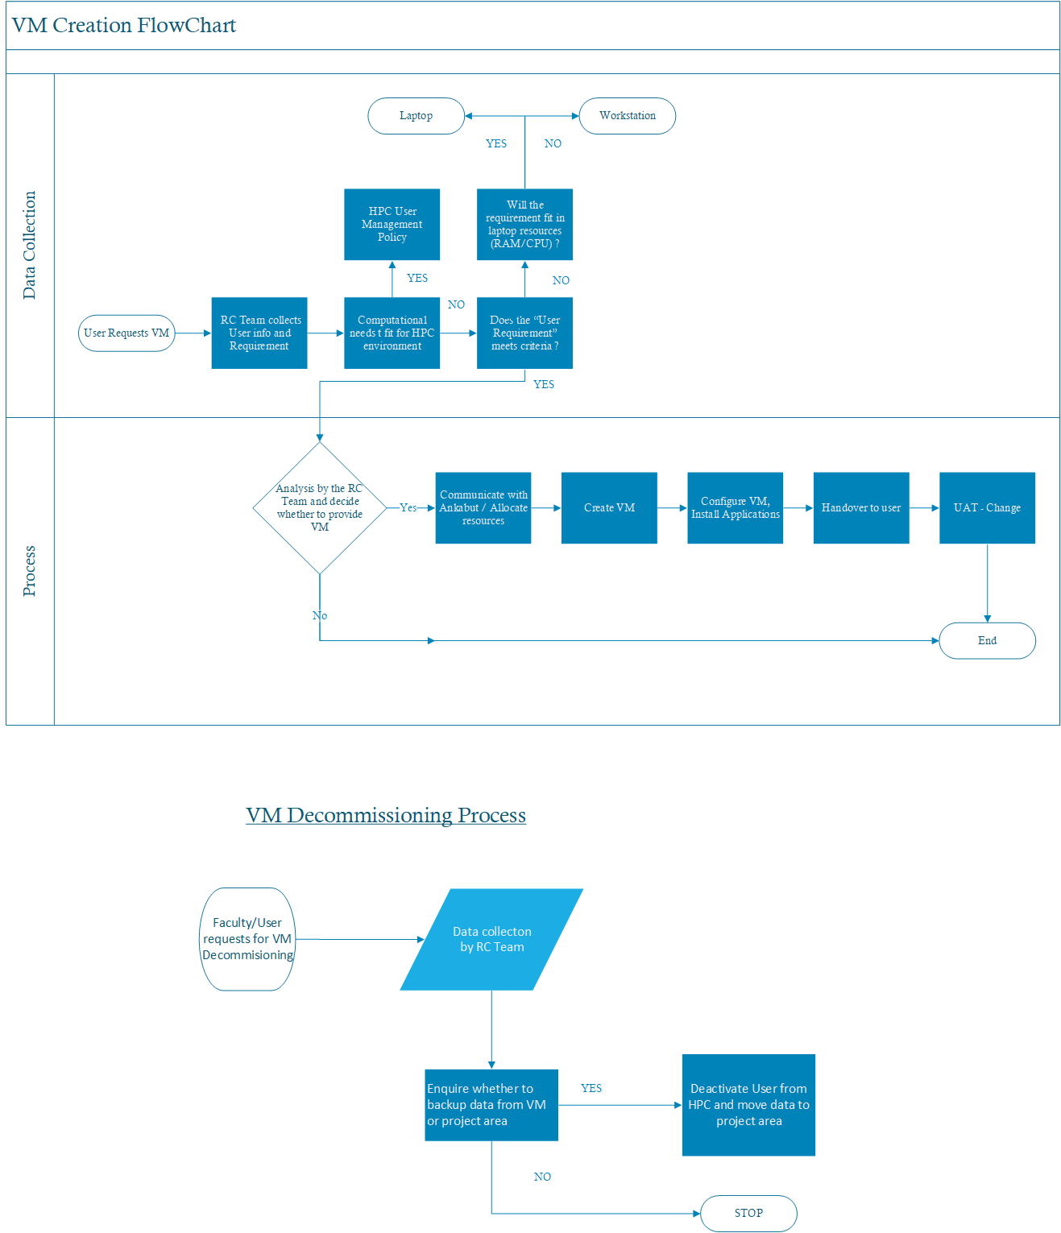

Policy Review and Maintenance
This policy will be reviewed and updated, annually, or as needed, to ensure that the policy remains aligned with changes to relevant laws, contractually obligations and best practice.

Supporting Policies and Documentation
Staff are also asked to read this policy in conjunction with other related policies and guidance documents defined below:

    - Password Security Policy
    - Information Security Policy
    - Privacy and Personal Data Protection Policy

Advice
For further advice, please contact the RC Team at researchcomputing@ku.ac.ae or refer to the RC team wiki pages at https://wiki-researchcomputing.ku.ac.ae.

